Tirana Connectivity Forum 2019: Call for papers
July 15th, 2019

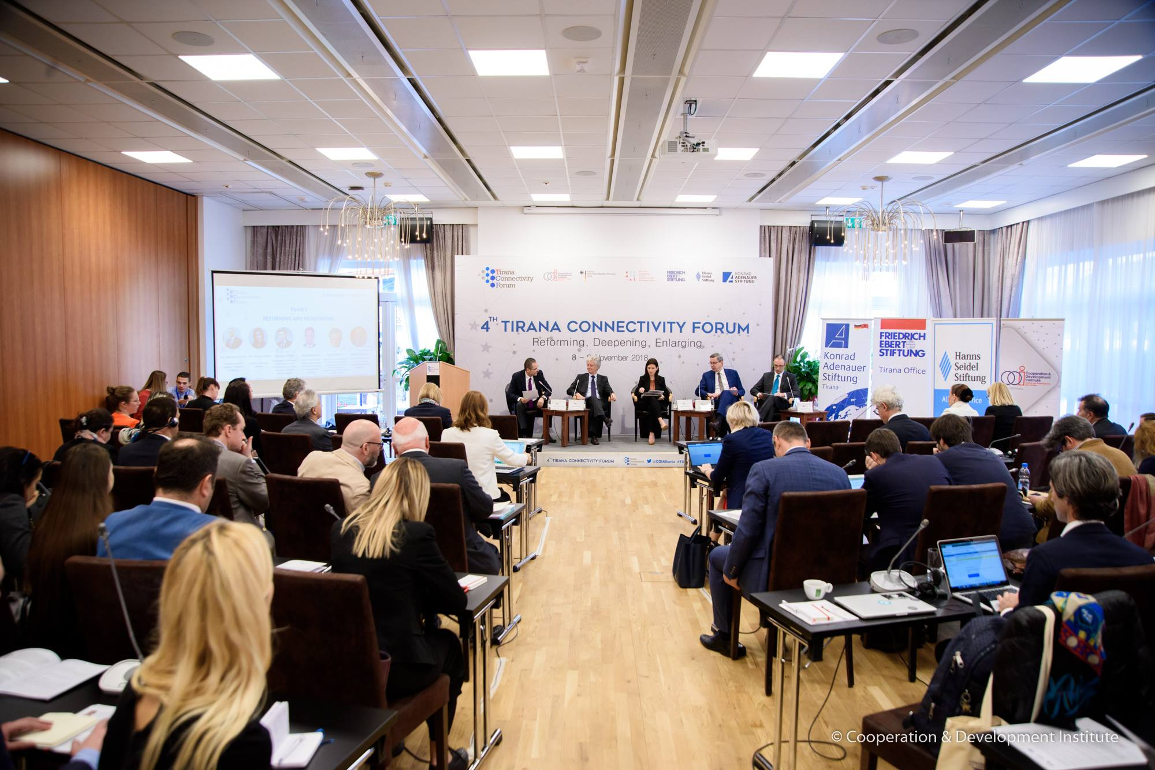
In the framework of Tirana Connectivity Forum 2019 – TCF19, Cooperation and Development Institute is happy to announce the First Open Call for Papers for this year’s edition.
TCF19 will take place in Tirana on 29-31 October 2019. Its purpose is twofold: i) monitor the progress of connectivity initiatives during the previous year, and; ii) create a stimulating platform that generates new ideas and concrete policy recommendations regarding connectivity and its contribution to the Enlargement and WB6 reforms.
In its 5th edition in its first day TCF will take stock of the progress made in the Connectivity Agenda with focus on energy, transport, and on people-to-people connectivity. Since the Berlin Process Summit of Vienna in 2015 and the endorsement of the first infrastructure connectivity projects, their implementation has substantially advanced, while new projects have entered the implementation pipeline. As a result, their impact is becoming visible at the same time as new challenges are appearing. But, regional institutional cooperation is showing strains as illustrated by the gap between transposition and implementation especially in the sector of energy. People-to-people component has successfully gone through the “inception phase” – the youth exchanges are becoming the new normal.

The second day will focus on challenges of Enlargement and how connectivity can contribute in WB6 reforms and on their path to EU membership. In an ever changing environment marked by Brexit and decoupling of supply chains, WB6 need stronger institutional relations with their European partner institutions, increased peer-to-peer scrutiny, accelerated pace of sector integration, higher involvement of WB6 peers to selected EU fora, higher and better inclusiveness, as well as pragmatic application of conditionality based on institutional integrity compliance. This requires a systemic shift in the way WB6 institutions are supported by their European peers.
During this edition we will try to discuss on the role and contribution of Berlin Process from 2020 onwards. How better connectivity can solidify the WB6 achievements during last 25 years, as well as push the EU Enlargement agenda? The Poznan Summit while underlining the importance of spatial connectivity for WB6 to catch up with their EU peers, also recognized the many challenges met during implementation, and especially the role and capacity of local institutions. Planned stock-taking events in Sarajevo and Pristina illustrate the need for intense coordination amongst WB6, as well as between WB6 and EU. The binary organization by Bulgaria and North Macedonia for the 2020 WBS is an opportunity to shift the connectivity vantage point towards Western Balkans.
Tirana Connectivity Forum has now become an annual benchmark for experts, researchers, academicians, CSO and policy-makers involved in EU Enlargement in WB6, in Regional Cooperation, and Connectivity dynamics. To make the most of this high level gathering, this year CDI and its partners – Konrad Adenauer Stiftung, Friedrich Ebert Stiftung and Hanns Seidel Stiftung – will provide a platform for the best research papers that fall into the TCF19 scope.
We particularly will welcome papers from scholars, researchers and professionals reflecting the topics and questions which be broadly discussed during this edition, such as:
- How the big infrastructure projects impact growth, socio-economic development and / or institutional context of WB6?
- What are the main challenges faced during implementation of the Regional Economic Area?
- How the gap between law transposition and implementation can be narrowed down?
- Can Berlin process contribute to re-launch Enlargement? If yes, how?
- Connectivity and Geopolitics applied to WB6
- Is the current Enlargement policy ensuring the inclusiveness of WBs in the “new” EU?
- Can EU use elements of “Transgovernmental governance method” in the Enlargement policy?
- Are there any regional societal connectivity patterns and joint migration challenges in WB6?
- What is the role of youth and civil society in influencing and shaping national and regional debates?

How to apply:

All submissions to this call must be individual and include:
- the CV of the Applicant (Maximum 3 pages);
- the title and paper proposal (Introduction 200 words max.; main body 1,000 words max.; and conclusion 300 words max.) in English language.

The authors should clearly list the topics abovementioned that were primarily addressed in the paper. Submitted papers should include concrete policy recommendations.
Submissions must be sent electronically to info@cdinstitute.eu. It is requested to insert in the subject of the email “CfP TCF19”.

Make sure to include in the CV and/or email: Contact information: name, e-mail address, and academic affiliation of the applicant.
Deadline for submissions is 11 August 2019.

The organizers will fully cover travel and accommodation expenses of two selected applicants to be part of the discussions during all the open sessions of the Forum. The two selected papers will be part of the Forum Report which will be published and promoted in the first quarter of 2020.

