Side Event 3 “Energy: Regional Cooperation and Good Governance”
16 November 2018
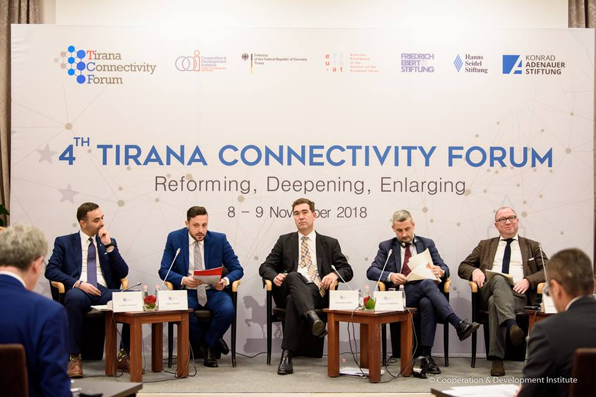

The side event on Energy focused on regional cooperation in the energy sector, specifically on the regional policymaking for energy generation and distribution, as well as on the implementation challenges of large projects the Western Balkans. The panel was moderated by Mr, Enio Civici, Director at Scan TV News in Albania.
Mr. Valdrin Lluka, Minister for Economic Development in Kosovo, pointed out the new Kosovar investments on Energy generation in Kosovo and the country’s commitment to EU targets in ensuring that 25% of their energy generation comes from renewable energy. Moreover, Kosovar government will shift 120MgW from HPP to Solar and Wind. He stated that ‘The new power plan is very important for Kosovo and for the region, and especially for Albania, but the challenge remains with the newly built transmission line between two countries that hasn’t been working. This causes a loss of 3 million per year only to Kosovo. The high voltage line, a German-financed investment, has not been used due to the unresolved conflict with Serbia stemming from the transmission agreement signed in 2013. EU is a sponsor of a joint energy market in the region but Kosovo cannot implement it because of this unresolved issue with Serbia.’ The minister underlined that German government is acting as intermediary in this conflict and that Albania has been helping as well. If we are talking as a region, talking about one economic area, we need to cooperate and of forget the past and focus on the future.’
Deputy Director of the Energy Community Secretariat, Dr. Dirk Buschle, elaborated on the importance of the implementation. The WB6 have the same legal DNA as EU, but there is a huge gap between transposition and implementation: only 43% or rules and regulations have been implemented.
The enforcement procedure is a hybrid one: half legal and half political. We need to consider creative ways of resolving disputes by using mediation and / or dispute resolution with the help of a strong external partner such as Germany. He stated that ‘the South-East Europe and the WBs have a lot of issues in common. Sometimes you do not see the real border going between member states and non – member states, but there is a joint legacy, joint past and joint problem to overcome. This is typical for the region, as it has to go out of this ‘sector mentality’ designed during communism. This is the first transition that our countries are still engaged in.’ Dr. Buschle mentioned that ‘Climate change is the second energy transition. It requires new instruments. How we all cooperate with each other…this will not work through confrontation mechanisms, it will work through cooperation mechanisms, through moderation, through looking at the problems that affect us all together.’ EnC will adopt the latest EU Clean Energy Act.
Mr. Fabio Tambone, Director and Head of External International Relations at the Italian Regulatory Authority for Energy, Networks and Environment (ARERA) commented on the regional cooperation: ‘We believe the integration of the Balkans in the electricity market is the future. The Interconnection cable with Montenegro, which will open a new corridor for electricity flows coming from other countries, will hopefully open a real market in this country.’ Starting from energy, we can really build a very important region for Euro-Mediterranean cooperation. He put the emphasis on strong institutions and how ARERA is supporting this.
The institutional cooperation in Energy is based on: i) adoption of a common regulatory framework; ii) traditional capacity building approach; and, iii) usage of multilateral platforms. He ended by encouraging Albanian authorities to increase TAP footprint in Albania by building up a distribution network in the country, so that it can get more than royalties.
The discussion followed with Prof. Matthias Dornfeldt from University of Potsdam bringing a perspective of energy security and geopolitics in the policymaking in the region and across Europe. He stated that ‘…since 2005, we have the EU South-Eastern Community and there are three key points: getting additional gas and oil through the region; South Europe to diversify the import of fossil fuel from other regions, and the electricity community cooperation which is more or less realized.’ Commenting on the Trans Adriatic Pipeline, Prof. Dornfeldt stated that except being partially a political project, ‘the Southern Corridor is brining gas from Azerbaijan in 2022. In total 10 billion cubic meters, 1 billion stays in Greece and Bulgaria, and 9 billion cubic ending up in the rest of Europe.’ He continued by concluding that ‘these times the question is who is willing to invest. We have been discussing the Ionian-Adriatic pipeline, but for it to be realized in order to bring gas from Albania via Montenegro, Bosnia and Herzegovina, to Croatia, we therefore need additional volumes of gas, and we do not have them. From 10 billion, 9 billion will go to Italy.’

