Spotlight on Transport: Adjustment Costs and Governance Challenges at Side Event 1 of Tirana Connectivity Forum
14 November 2018
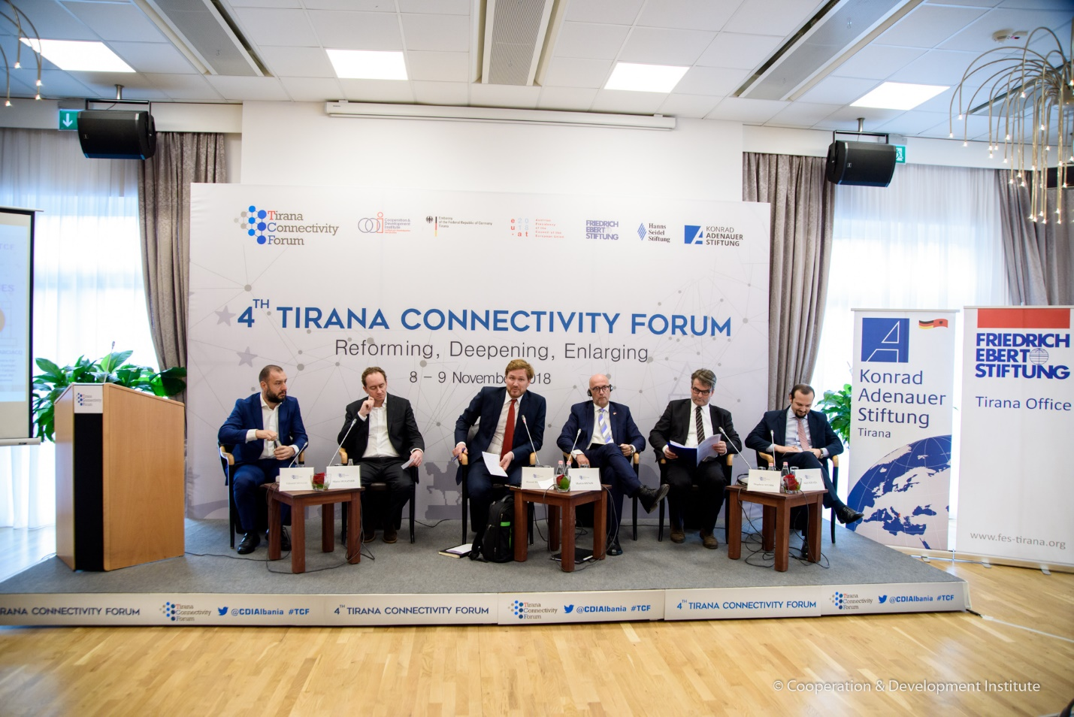
The first side event of TCF ’18 focused on why are better roads and railways needed in the Balkans, the governance challenges that are encountered during their implementation, the importance of including citizen’s interest in investment work or the need to invest in micro-connectivity. The moderator of the panel, Dr. Florent Marciacq from Austro-French Centre for Rapprochement in Europe, Vienna and Senior Fellow at Centre International de Formation Europeenne opened the debate by stating that the region has always been important in connecting East and West since the Roman Empire times, and that big powers have always invested in infrastructure connectivity in this region.
Dr. Mario Holzner, Deputy Director of Vienna Institute for International Economic Studies stated that ‘overall investment in the Western Balkans is high (~25% of GDP) and includes to a large extent investment in construction. However, investment in infrastructure is only at about 1% of GDP. Before the outbreak of the global financial crisis, it was at about 2% of GDP and was subsequently one of the first victims of the crisis’. He continued by summarizing some policy conclusions, i.e ‘intensity of involvement is important; Europe should step up its infrastructure investment support; and composition of funds matters. Further loans will increase the indebtedness of these vulnerable economies. Infrastructure funds could be used as a bargaining chip and reward in the negotiations for political reconciliation in the region’.
Whereas Mr. Eduard Shalsi, Member of the Albanian Parliament followed by saying that ‘Albania inherited a system with a lack of human capacities and decision making in the sector.’ Therefore, – he continued, – it is important to build a system and a vision before investing. The government has prioritized investment based on lessons learned. How to invest the money and where, instead of how much. It is now prioritizing investment in strategic areas that have a growth potential like building an airport and roads in the South of Albania,’ – concluded Mr. Shalsi.
Mr. Martin Henze, Chairman of Transport Commission of the Economic Council of CDU continued by emphasizing the need for liberal policies and stable policies to boost investment in infrastructure. Mr. Henze argued that ‘the EU needs a comprehensive economic strategy where the Balkans will take their place, as regards the economic model and infrastructure investment.’ He then stated that ‘it was a surprise that Albania started to use the PPP model on infrastructure investment as that has been avoided by EU member states as not a productive mechanism.’
Mr. Akil Kraja, Member of Tirana Municipality Council, stated that the ‘Balkans is not well – connected and it looks like a ghetto within the ghetto. However, – he continued, – the citizens are seeking for more connections and more roads.’
Finally, Dr. Stephen Stork from the EU Delegation in Tirana argued that the ‘EU has cooperated on the Single Pipeline Projects that funds the best projects with the best added value for the countries of the region, as this is where the needs meet the demand.’ He continued by saying that ‘EU funds are now results and outcome oriented. The IFIs and private funds should produce measurable outcomes and show how individual citizens profit or how do these projects contribute to the cohesion and cross-border cooperation.’ Mr. Stork also emphasized that the ‘national systems that are used to translate these projects should be aligned with EU principles in terms of public procurement, broad competition, best value for money, environmental assessment, etc.’

