3rd Tirana Conference on Berlin Process “From Trieste to London: Stocktaking and Future Scenarios for the Berlin Process”
15 November 2017
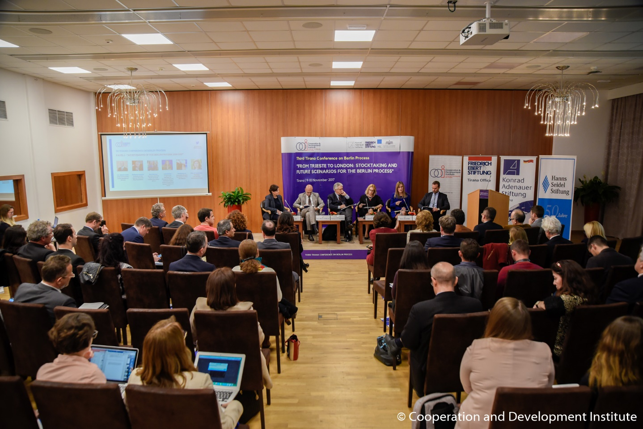
The 3rd Tirana Conference on Berlin Process “From Trieste to London: Stocktaking and Future Scenarios for the Berlin Process” (TCBP) was organized by the Cooperation and Development Institute (CDI) in Tirana on 9-10 of November, in partnership with Konrad Adenauer Stiftung, Friedrich Ebert Stiftung and Hanns Seidel Stiftung, and in cooperation with Albanian Ministry for Europe and Foreign Affairs. TCBP are designed to provide content on Berlin Process (BP) as well as to promote networking amongst BP stakeholders and thematic analysis of the Berlin Process. In line with the previous conferences, 3rd TCBP contributed to the visibility and impact of the Berlin Process, while emphasizing the need for benchmarks and monitoring.
The 3d TCBP started with the welcoming speech on behalf of the three German Foundations by Dr. Walter Gloss, Director, Director of Konrad Adenauer Stiftung in Tirana and by Mr. Ardian Hackaj, Research Director at CDI. In its Keynote Speech Mr. Etjen Xhafaj, Deputy Minister of the Albanian Ministry for Europe and Foreign Affairs, emphasized the ownership, commitment and resources that Albanian Government has contributed with since the beginning to this process, in regional cooperation and connectivity.
The first panel “Achievements of the Berlin Process: 2014-2017” underlined the importance of the Berlin Process as a cooperation initiative complementing the EU integration process, – not replacing it. H.E Italian Ambassador Alberto Cutillo argued that WB6 region performs better thanks to this process. Moreover, the panellists brought into attention the importance of local ownership of the initiative, its contribution to economic development and the added value of the Process in putting in the agenda pending or new bilateral issues in the region. Speakers stated that there is need to concrete and speedy contribution to RYCO in terms of financing and other infrastructure. WB6 civil society should participate not only as participants, but as core contributors to the process to increase its visibility and impact on the ground.
The second panel discussed upon the topic “Connecting WB6 market(s): state-of-affairs of connectivity infrastructure projects”. The speakers stated that there is a need for more and efficient cooperation and coordination between the WB6 during the preparation of National Single Projects Pipelines and of Economic Reform Programmes. WB need to become a more connected regional market. It was stressed that connectivity is about getting the most use out of the infrastructure. The governments need to deliver in their reforms beside projects, in order for the countries to be more attractive and maximize the benefits out of infrastructures.
The third panel “Boosting WB6 growth to accelerate convergence with EU”, emphasized the need for the engaged political and economic structural reforms in the region to continue. The WB6 region suffers from low public investments necessary to achieve not only economic convergence. The use of the cohesion funds has been the engine growth in the new Member States. In the WB6 case, to compensate for the trade deficit with the EU and to support growth and convergence, the WB6 countries need additional sources of funding. Innovative EU-backed financial instruments (beyond IPA III) must be actively explored immediately. Investments in the human capital should complement those in infrastructure. The territorial cooperation programmes can play a role in involving the local territories and valorizing them in the framework of the connectivity projects and infrastructures.
The last panel, as the title also suggests “Berlin Process: Reinforcing the Momentum” discussed about the future of the process ahead of 2018. If Western Balkan countries want to continue the Berlin Process, they need to maintain the level of ownership and commitment. Berlin Process is a matter of staying focused, showing interest and preparing in the road to EU membership. Regarding the Regional Economic Area, the Albanian Coordinator Mrs. Milena Harito argued that local ownership and initiatives on eliminating market barriers remain a core condition. The preparations that Poland, as a friend of EU enlargement, is doing in order to join the Process, and host the Western Balkans Summit in 2019, will focus in offering its insight as a new member state with similar patterns of history with that of the Western Balkans. Meanwhile the UK presidency of the Summit 2018 will focus on Inter-connectivity (Regional Economic Area, transport, energy), Entrepreneurship, Youth, Security, Anti-corruption, fight against Terrorism.
Following, the London conference in 2018, the 4th Edition of Tirana Conference on Berlin Process will be held in October 2018.
Photos from the Conference can be viewed here.
The agenda, discussion points and list of speakers can be consulted here.

