Regional Conference “From Trieste to London: Stocktaking and Future Scenarios for the Berlin Process | Tirana, 9 – 10 November 2017

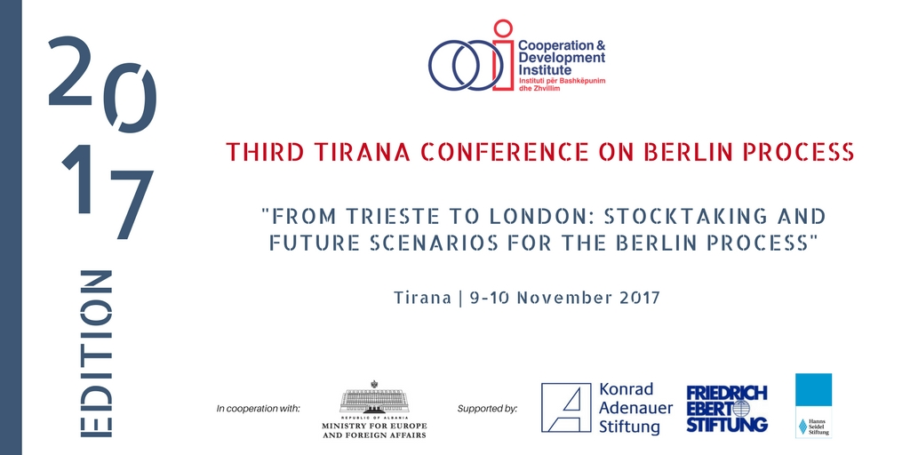

Background Note
The year 2018 will be the last one of the current cycle of the Berlin Process. Started in 2014 as an initiative of Chancellor Merkel, the Berlin Process has provided a unique platform to enhance WB6 regional cooperation, to support regional connectivity projects, and to encourage the engaged reforms by WB6 on their way to European Union membership. All partners agree the process must continue beyond 2018, as it remains the most important initiative assisting WB6 countries to better prepare for EU membership.
The WB6 Summit in Trieste in July 2017 confirmed the unequivocal support for the EU perspective of the WB6 countries. The strengthening of the rule of law, of fundamental rights, and of economic development, as well as the WB6 commitment to good neighborly relations, and the support to engaged reforms, were all mentioned as meaningful achievements. Connectivity, regional economic integration, private sector development, youth, good governance / fight against corruption, prevention of migration and fight against extremism, were discussed and included in the Trieste Summit Final declaration. All the WB6 leaders came back home drumming their successes in Trieste.
But what does it mean in practical terms? How does Trieste Summit agenda impact the regional WB6 cooperation? How the Connectivity Agenda and the Regional Economic Area will contribute to regional growth and how much? How the approved connectivity projects are being implemented? Can Berlin process address economic disparities between WB6 and EU member countries? How Brexit will impact the EU financial contribution to WB6? How can 2018 London Conference contribute to this debate? What is the vision and the expectations for the future of the Berlin Process?
These questions are of strategic importance for all the partners of WB Summit Series. The 2017 Tirana Conference aims to address many of them. It is the third event in a series of academic conferences organized by Cooperation and Development Institute (CDI) in cooperation with Konrad Adenauer Stiftung, Hanns Seidel Stiftung and Friedrich Ebert Stiftung. The first conference in 2015: “Albania in the Berlin process: current achievements and upcoming challenges for the Paris summit“, produced a comprehensive policy document on the Berlin Process focusing on its roots, definition, approach, actors, mechanisms and funding opportunities, as well as the institutional, legal and policy framework. The second conference in 2016: “Monitoring the Berlin process: from Paris to Trieste“, studied its governance architecture, its impact and contribution to the EU path of the WB6. It particularly analyzed the main achievements in connectivity infrastructure projects, the preparation of Economic Reform Programs, the National Single Project Pipelines, and RYCO.
One year before the last Western Balkans Summit, the 2017 Third Tirana Conference will provide a platform where Berlin process stakeholders will analyze and discuss about its current achievements, and the challenges ahead. The 1st panel will outlay the complementarity and synergies of the Berlin Process with the EU integration endeavor of the WB6. Achievements such as the increased multi-actor regional consultation and cooperation, the advancement of regional perspective in policy-making and cooperation, and the commitment to the engaged reforms, will be covered.
The 2nd panel will provide a comprehensive assessment of the advancement of infrastructure projects (by sector, budget, financing mechanisms, stage of advancement, challenges, etc.), completed with the soft measures undertaken in the framework of the Berlin process. The debate is expected to place the connectivity infrastructure in the Balkans socio-economic context, and bring out its impact and interaction with local manufacturing, employment, and the local value chain.
The 3rd panel will focus on the contribution of Connectivity Platform in the desirable Balkans growth rate and on the reduction of economic disparities between the Balkans and the EU. The focus will be on the sources of growth in the region; on the importance of increasing the investments in the local human capital; and on specific EU measures that can practically and meaningfully contribute to achieve WB6 growth targets and reduce its economic disparity with the EU member countries.
The last panel will look beyond the London Summit, providing the elements of a common vision on the future of Western Balkans regional cooperation, on the interaction with their EU membership path, on the need for a coherent governance architecture, and on the role of the European citizen in this process.
The participants will come from government institutions involved in planning and implementing connectivity projects, from legislative bodies – them being WB6 national or from EU, from private sector, IFI, diplomatic representatives accredited in Albania, think tanks, academia, and other Berlin Process stakeholders.
The panelists and speakers will present their assessment on the above issues, and will provide insights from varying perspectives and experiences. The speakers will act in their personal capacity, not necessarily reflecting positions of countries or institutions, which they represent. In this way, not only different views will be presented, but also a better mutual understanding of diverging positions can be reached and proposals towards a shared understanding of the achievements of the Berlin Process and of a common vision for its future.
The conference will take place from Thursday 9 November 1400hs until Friday 10 November, 1400hs.
The 2017 edition of Tirana Conference on the Berlin Process is organized by Cooperation & Development Institute in partnership with Konrad Adenauer Stiftung, Hanns Seidel Stiftung and Friedrich Ebert Stiftung, and in cooperation with Albanian Ministry for Europe and Foreign Affairs.

