TIRANA CONNECTIVITY FORUM
‘Reforming, Deepening, Enlarging’

8-9 November 2018, Hotel Rogner, Tirana

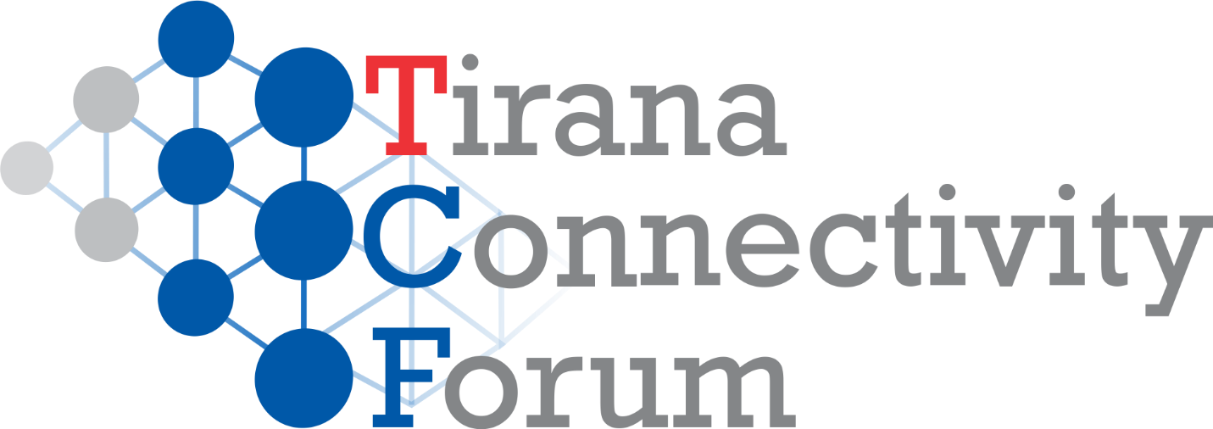

This year’s event comes under a new format and name to continue the tradition of our annual Conference in ‘Berlin Process Series’, organized by Cooperation and Development Institute - CDI and supported by Konrad Adenauer Stiftung - KAS, Friedrich Ebert Stiftung – FES, and Hanns Seidel Stiftung – HSS. The three previous editions of the ‘Berlin Process Series’ Conferences were designed to provide in-depth analysis of the Berlin Process Summits, as well as what changed in between two summits regarding the WB6 Regional Cooperation and WB6 Connectivity Agenda. The event has now become an annual benchmark for experts, researchers, academicians, CSO and policy-makers involved in EU Enlargement in WB6, in Regional Cooperation, and Connectivity dynamics. TCF18 will address the progress of EU Connectivity Agenda projects in transport, energy and youth, focused on their governance; and the contribution of connectivity to WB6 accession to EU.
On Thursday, November 8, three thematic panels will take place:
1. Transport: Adjustment Costs and Governance Challenges This panel will focus on WB6 infrastructure adjustment costs induced by the Connectivity Agenda. It is organized in partnership with KAS. The focus will be on the region's deficit on transport infrastructure that Berlin process dynamics has "uncovered"; the Berlin Process contribution; and on the role that governance factor amongst other, has in tackling them. Main topics are:
- challenges of transport connectivity in WB6 (such as poor coverage, micro-connectivity, weak institutional framework for public investment management, poor regional coordination, etc.)
- adjustment costs on connectivity infrastructure and contribution of Berlin Process-induced dynamics;
- the "transport connectivity factor" in Enlargement Strategy 2018, in EU Financial Framework 2021-2027, and on Poznan Summit Agenda.
2. Energy: Regional Cooperation and Good Governance This panel will deal with challenges in the way towards an integrated regional energy market, integrated in the EU internal energy market. It is organized in partnership with FES. The focus will be on achievements and challenges of regional energy generation and of transmission networks; the cross-border cooperation, and; the role of good governance in the implementation of acquis in energy generation with transmission projects.Main topics are:
- current situation in the WB6 Energy Market on adoption of soft measures; Cross-Border issues with governance challenges regarding connectivity project management with enforcement mechanisms; interaction with the WB6 citizen, etc.;
- Energy Union roadmap in the Enlargement Strategy 2018, in EU Financial Framework 2021-2027, and on Poznan Summit Agenda.
3. Youth: Connecting to their own country The youth panel will deal with people-to-people connectivity, focused on Balkan youth. It is organized in partnership with HSS. The focus will be on bottom-up connectivity angle as seen and experienced by Balkan youngsters, their relation with home country (i.e. how to connect them with their future in the region through education with employment); how to connect with policy-making and reform dynamics by improving their participation in the democratic processes. Main topics are:
- youth connectivity challenges: (i) geographical (i.e. inter-country / intra WB6-EU); (ii) "vertical": studying with career-wise; (iii) democratic: increased participation in democratic processes, etc.;
- "youth connectivity factor" in Enlargement Strategy 2018, in EU Financial Framework 2021-2027, and on Poznan Summit Agenda.
On Friday, November 9, TCF18 will analyze the contribution of Berlin process and of engaged reforms to Enlargement. The second session will focus on the interaction of EU Deepening with the Enlargement on selected sectors such as migration / security / etc.; how connectivity and regional cooperation support reforms engaged in WB6. The panel ‘Reforming and Negotiating’ will underline the necessity of use of “multilayered connectivity” concept and of institutional governance, to complement the normative and institutional approach of Enlargement. It will discuss the expect results, respective cost and relevant challenges expected by the implementation of 6 Strategic Initiatives; the role of key reforms in negotiation dynamics, and the reinvigorating contribution of the Berlin process. Main topics are:
- 6 Strategic Initiatives and their connection with Berlin proces; their goals, costs, resources and expected impact;
- "connecting" and "integrating": improvements / insufficiencies / other relevant issues.
The last panel “Deepening and Enlarging” will turn the attention of participants on EU - Western Balkans polity and EU's leverage on WB6 policy-making and in furthering the WB6 reforms. Also, EU can use Enlargement dynamics to stimulate and sustain its own current debate on European values. This panel will cover: (i) interaction of EU Deepening with Enlargement on selected sectors such as migration / security / etc.; (ii) how connectivity and regional cooperation support reforms engaged in WB6; and, (iii) impact and visibility challenges of Enlargement. Main topics are:
- potential contribution of WB6 in dealing with EU "hot issues" such as migration / security / etc.;
- the role of Berlin Process in supporting and monitoring reforms in WBS and amplifying EU support for front-loading, screening, scrutiny of governance, impact with visibility, etc.
Tirana Connectivity Forum is organized this year with the partnership of the German and Austrian Embassies in Tirana.Participation is upon invitation only.

