TIRANA CONNECTIVITY FORUM 2019
29 – 31 October 2019

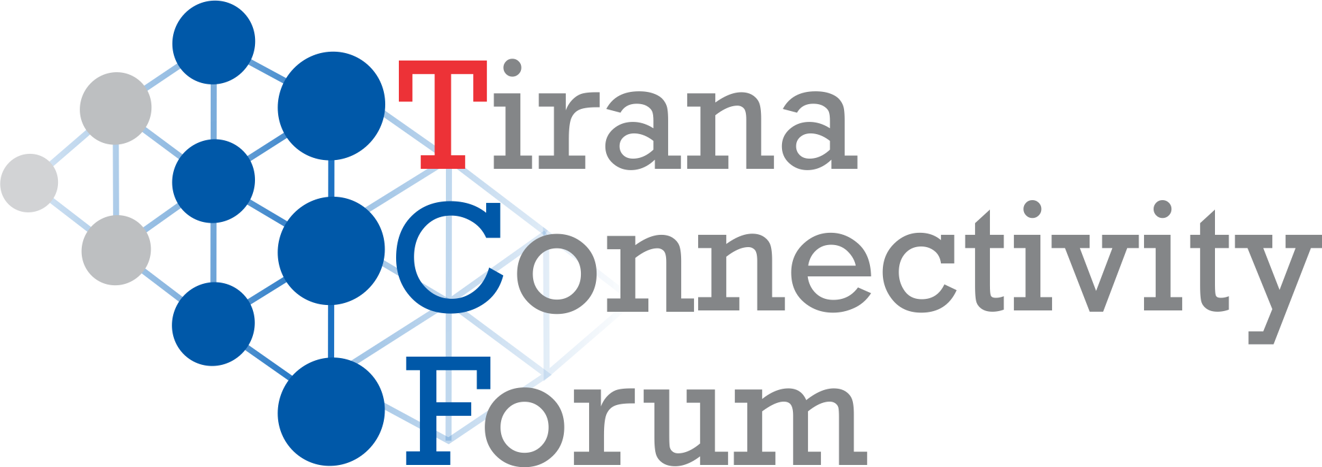

The 5th edition of TCF will take stock of Connectivity Agenda progress with focus on energy, transport, and on people-to-people components. Since the Western Balkans Summit (WBS) of Vienna in 2015 and the endorsement of the first connectivity projects, project implementation has substantially advanced, while new infrastructure projects have entered the pipeline. As a result, Connectivity Agenda impact is becoming visible at the same time as new challenges inherent of implementation phase are appearing.
Moreover, regional institutional cooperation is showing strains as illustrated by the regional trade conflicts, and the gap between transposition and implementation of legal framework. People-to-people component has successfully gone through the “inception phase” – the youth exchanges are becoming the new normal.
Two external factors are directly impacting connectivity in the Western Balkans (WB6): intra- EU developments illustrated by the rise of populism, challenges to the rule of law and Brexit phenomena; and the decoupling of global supply chains translated in increasing pressures that it puts on globalization. While WB6 region is promoted as an optimal FDI destination, geopolitics is interfering with economics impacting firm decision on new value chains, or the Balkan countries trade patterns. The slowing down of EU Enlargement has exposed the fragility of deep-cutting reforms engaged by the WB6 institutions, catching those very institutions in the middle of their transformation process.
The side event on Wednesday morning, 3th of Oct. will look at the contribution of Poznan WBS 2019 into youth policies and developments in Western Balkans. The focus will be on the role that digital economy has on the Balkan youngsters main concern: studying and employment.
The afternoon panels will set the scene for the analysis and debate of the connectivity phenomena in Western Balkans. During the keynote addresses, special invitees will provide an institutional overview of the role and challenges that connectivity projects and regional cooperation have for the Western Balkans region, on their path to EU. The concept of multi- dimensional connectivity and its role in transfer of knowledge and on the convergence dynamic, will be presented as well.
The sub-sequent panels will cover the Connectivity Agenda spatial component: i.e. energy and transport, as well as p2p. In the energy panel, after the presentation of the achievements in energy infrastructure, the debates will focus on regional institutional cooperation, geopolitics and energy security implications, and on Balkan countries challenges impacting the flow between transposition and implementation of legislative framework.
The transport panel will provide an overview of the implementation of transport projects under the Connectivity Agenda, complemented with the challenges they are meeting during their implementation. Special focus will be given to the local institutional capacity and of their role in all the phases of project cycle i.e. planning, construction and operations.
Youth exchanges and migration flows will be the subject of the P2P panel discussions. The increasing number of youngsters visiting the neighbor countries and their immersion in neighbors’ cultures are the biggest investment for the European future of the region. However many individuals are cutting short their journey to EU by migrating. This phenomenon, which is affecting especially the middle class, is depriving Balkan countries from their best and dynamic part, as well as damaging the functioning of local democracy.
In October 31st , TCF19 will put the connectivity in the larger WB6 context by analyzing its interaction with geopolitics and the deep-cutting reforms engaged in the region in the view of EU membership. After taking stock of the current achievements and upcoming challenges of the Western Balkans for 2020, the participants will focus on region’s integration dynamics, consequences of de-globalization and the future scenarios.
As a multi-layered phenomenon, connectivity offers a unique view of the inter-linking between infrastructure projects and the context in which they are implemented. In the panel connectivity and geopolitics, special attention will be paid to emerging patterns of supply chains in the WB6 countries, to the dynamics of regional trade conflicts, as well on the importance that better connectivity has for anchoring the WB6 to EU.
The last panel will focus on regional connectivity and its inter-relations with the deep-cutting institutional reforms engaged in WB6. Being “well governed” is a very important transition quality that makes possible an increased institutional efficiency, bigger impact and secured sustainability of any investment in the adoption of Copenhagen Criteria. In an ever changing environment, stronger relations between WB6 and European institutions, increased peer-to- peer scrutiny, sector integration, involvement of WB6 peers to selected EU fora, higher and better inclusiveness, or conditionality based on integrity compliance require an institutionalized connectivity between European and WB6 institutions.
What will be the role of Berlin Process from 2020? How better connectivity can solidify the WB6 achievements during those 25 years, as well as push the Enlargement agenda? The Poznan Summit while underlining the importance of spatial connectivity for WB6 to catch up with EU peers, also recognized the many challenges met during implementation, and especially the role and capacity of local institutions. Planned stock-taking events in Sarajevo and Pristina illustrate the need for intense coordination between WB6. The binary organization by Bulgaria and North Macedonia of 2020 WBS is an opportunity to shift the connectivity vantage point towards Western Balkans.
The event has now become an annual benchmark for experts, researchers, academicians, CSO, WBS coordinators and other policy-makers involved in EU Enlargement in WB6, in Regional Cooperation, and Connectivity dynamics.

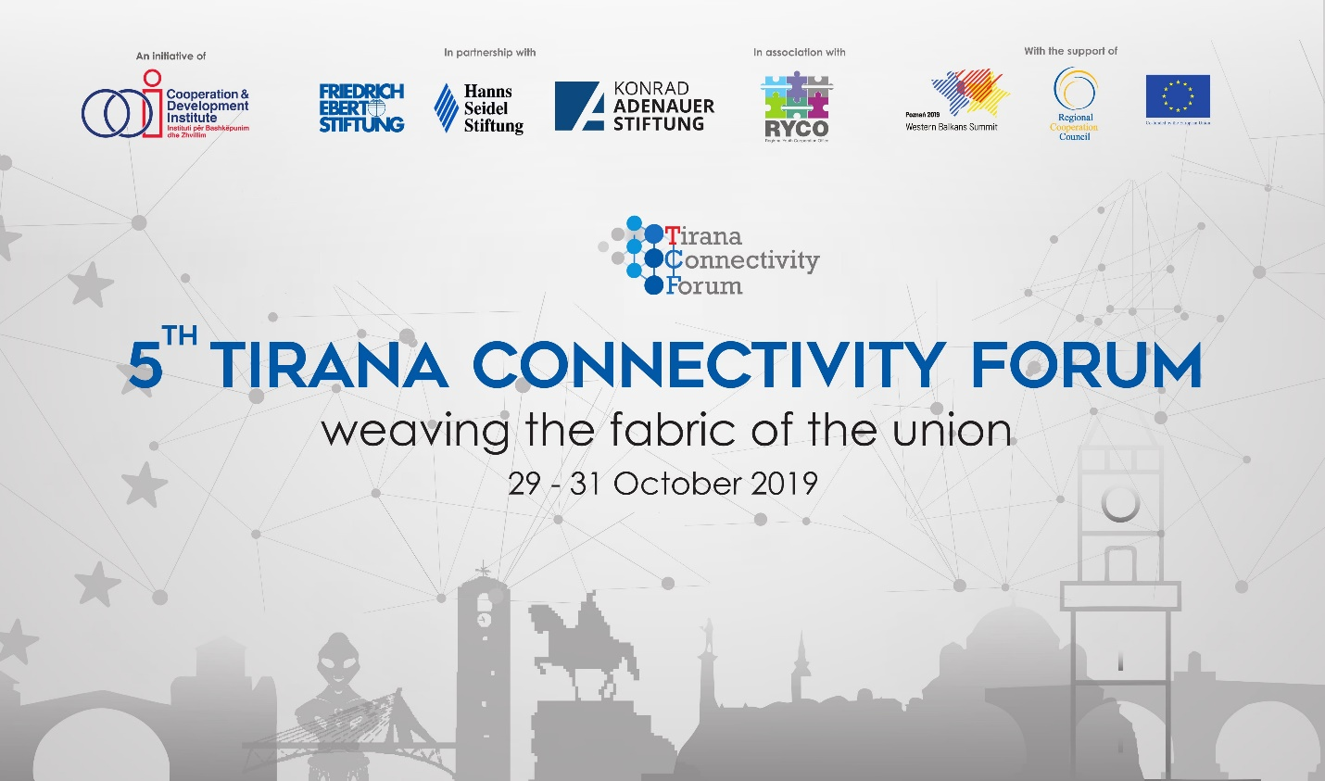

Tirana Connectivity Forum 2019 – PROGRAM

29 October 2019
15:00 - 18:00 SIDE EVENT. Western Balkans Youth Cooperation Platform (WBYCP) | Closed Session
30 October 2019
STATE OF AFFAIRS OF CONNECTIVITY IN WB6

09:30 – 11:30 SIDE EVENT. Youth Challenges and Digital Economy: Building on Poznan WB Summit

Welcome Address
- Klaus Fiesinger - Regional Director for Southeast Europe, Hanns Seidel Foundation
- Krisela Hackaj - Western Balkans Youth Cooperation Platform / Executive Director of the Cooperation and Development Institute

Keynote Speaker
Wieslaw Tarka - Coordinator of the Western Balkans Summit in Poznan, Ministry of Foreign Affairs
Panel members
- Daniela Boudinova - Special Coordinator for the Berlin Process Summit 2020, Ministry of Foreign Affairs of the Republic of Bulgaria
- Florensa Haxhi – Director General, Development Programs and Cooperation Unit, at the Prime Minister’s Office
- Frank Hantke – Country Director of Friedrich Ebert Stiftung - Prishtina Office
- Uranik Begu - Executive Director of Innovation Centre Kosovo
- Marta Szpala - Coordinator for the Think Tank Event of Poznan WBS, Senior fellow at the Department for Central Europe and the Balkans in the Centre for Eastern Studies
Moderator: Meliha Muherina - Young Bled Strategic Forum Programme Director, Project Manager / Centre for European Perspective (Slovenia)

13:00 – 13:15 Registration to Tirana Connectivity Forum 2019

13:15 – 13:30 Welcome and Rationale

Ardian Hackaj - Director of Research, Cooperation and Development Institute
Stine Klapper - Head of Office, Friedrich-Ebert-Stiftung (FES) in Tirana
Dr. Tobias Ruettershoff - Director of the Konrad-Adenauer-Stiftung (KAS) office in Albania
Dr. Klaus Fiesinger - Regional Director for Southeastern Europe of Hanns-Seidel-Foundation

13:30 – 13:45 Keynote Address | “Albania as a Western Balkans Critical Connectivity Nod for Transport and Energy”, from Belinda Balluku - Minister for Infrastructure and Energy of Albania

13:45 – 14:00 Keynote Address | from H.E Luigi Soreca - EU Ambassador to Albania

14:00 – 14:15 Keynote Speech | from Majlinda Bregu - Secretary General of the Regional Cooperation Council

14:15 – 14:45 Setting the Scene | “Multidimensional Connectivity and Western Balkans” from David M. Gould, Lead Economist and Program Leader in the East Asia and Pacific (EAP) Region, and Lead Author of “Critical Connections: Promoting Economic Growth and Resilience in Europe and Central Asia”, World Bank Group

14:45 – 15:10 Coffee break
15:10 – 16:35 PANEL 1. Regional Cooperation in Energy
Panel members

- Arben Ahmetaj - Chair of the Parliamentary Commission on Economy and Finance, Parliament of Albania
- Marko Radulović - Director General of Directorate for Energy and Energy Efficiency, Ministry of Economy, Montenegro
- Serafino Stajano - Head of Economic & Trade Sector, Embassy of Italy in Tirana
- Mathias Dorndfeldt - Assistant Professor for Energy Policy and Diplomacy at the University of Potsdam
Moderator: Arben Kllokoqi – Electricity Expert, Energy Community Secretariat

16:45 – 18:15 PANEL 2. Institutional Challenges in Transport Connectivity
Panel members

- David M. Gould - Lead Economist and Program Leader in the East Asia and Pacific (EAP) Region, and Lead Author of “Critical Connections: Promoting Economic Growth and Resilience in Europe and Central Asia”, World Bank Group
- Tiziano Onesti - Chairman of the Board of Directors of Aeroporti di Puglia S.p.A. and Trenitalia S.p.A.
- Nerejda Hoxha - Desk Officer in charge of Connectivity Reforms, Transport Community Treaty/ The Permanent Secretariat
- Alessandro Bragonzi – European Investment Bank Representative for Albania, Kosovo*, and North Macedonia
Moderator: Ardian Hackaj, Research Director, Cooperation & Development Institute

16:45 – 18:15 PANEL 3. People-to-People Connectivity and Human Capital
Panel members

- Djuro Blanusa - Secretary General of the Regional Youth Cooperation Office
- H.E. Peter Zingraf - German Ambassador to Albania
- Adelheid Feilcke – Head of the Europe Department at Deutsche Welle, Germany
- Endrit Shabani – Researcher, Academic, Activist / Oxford University, “Thurje” Initiative
- Ema Smolo - Communications and Project Assistant, Friedrich Ebert Stiftung Dialogue Southeast Europe

Moderator: Florent Marciacq - Deputy Secretary General & Research Fellow, Austro-French Centre for Rapprochement in Europe (ÖFZ, Vienna)
31 October 2019
CONNECTIVITY AND CONVERGENCE

08:40 – 09:00 Registration

09:00 – 10:00 Conversation with Eduard Kukan and Knut Fleckenstein | “Western Balkans on their way to EU”
Moderation by Georgi Gotev - Senior Editor of EURACTIV

10:00 – 10:20 Keynote speech | from Romana Vlahutin, Special Coordinator and Ambassador at Large for Connectivity in the European External Action Service
10:20 – 10:30 Break

10:30 – 11:50 PANEL 4. Connectivity and Geopolitics
Panel members
- Mario Holzner - Executive Director, Vienna Institute for International Economic Studies
- Daniela Boudinova - Special Coordinator for the Berlin Process Summit 2020, Ministry of Foreign Affairs of the Republic of Bulgaria
- Bojan Marijcik - Special Adviser to the Prime Minister of the Government of the Republic of North Macedonia for Euro-Atlantic Integration and Chief Technical Negotiator, Government of the Republic of North Macedonia
- Amanda Rohde - Senior Programme Manager at Friends of Europe
Moderator: Dusan Reljic- Head of SWP Brussels Office, SWP - German Institute for International and Security Affairs

12:00 – 13:15 PANEL 5. Country Reforms and Connectivity
Panel members
- Marzena Kisielewska - Head of South East Europe Division, Global Relations Secretariat, OECD
- Steven Blockmans - Head of EU foreign policy, Centre for European Policy Studies, CEPS
- Christophe Hillion – Professor of Law, University of Oslo, Norwegian Institute of International studies (NUPI) and Swedish Institute for European Policy Studies
- Pirro Vengu - Head of the Department of Transparency and Anticorruption (DATAK) at the Albanian Prime Minister’s Office
Moderator: Ardian Hackaj - Research Director, Cooperation & Development Institute
13:15 – 13:30 Wrap Up
17:30 – 19:00 WB6 after 2020 - Forward thinking roundtable | Closed Session
---
Participation to TCF 2019 is upon invitation only.
For more information, you can contact inva.nela@cdinstitute.eu.

