TCF18 Day 2 starts with the Keynote Addresses by the President of the Republic of Albania H.E. Ilir Meta and the EU Ambassador H.E. Luigi Soreca.
26 November 2018
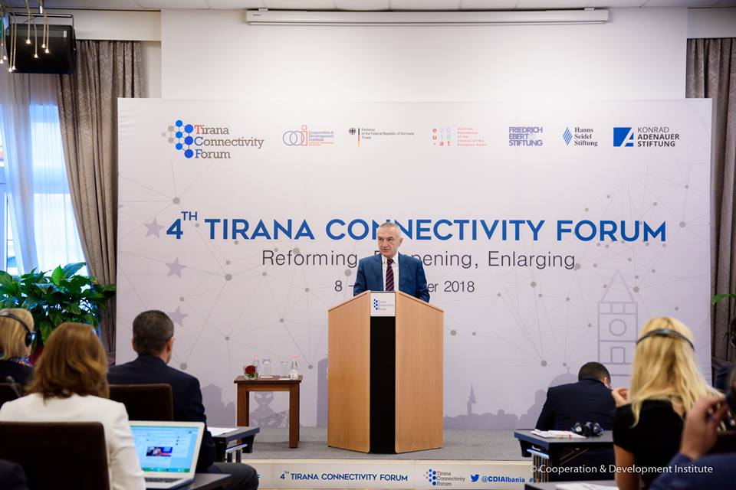
The President of the Republic of Albania, H.E Ilir Meta started his keynote speech by declaring that the Berlin Process has facilitated a more effective interconnection and interaction between the Six Western Balkans countries with the EU Enlargement Agenda. He added that ‘The summits of Berlin, Vienna, Paris, Trieste and London are significant evidence of this attention of EU toward Western Balkans. The geographic position of these Summits speaks clearly of the engagement and interest of the major European Union actors that carry a history of their strategic involvement in the Balkans.’
As a good example of the results of Berlin Process, he mentioned the attention devoted to youth, start of important initiatives related to closer recognition and regional reconciliation, vocational education, educational exchange programs, and so on. But he also added that there is much more to be done to increase employment opportunities and especially to stop the brain drain that is affecting our countries massively.
He closed his speech by saying that ‘Albania and Macedonia have all the opportunities to start accession negotiations next year and we should better focus all the energy in implementing the key reforms. I also believe that by maintaining focus on strategic objectives and reform agendas, the whole Western Balkans region has all the opportunities to advance faster towards full membership in the European Union’– he continued. ‘Let us be inspired by the philosophy of the youngsters who are born in the era of peace and who want ‘everything and now’, but in the meantime we should remain realistic because this process requires a lot of work and efficient cooperation.’
H.E. Luigi Soreca, EU Ambassador in Albania, started his speech by stating that 2018 has been an important year for the Connectivity Agenda in South-East Europe and the Commission’s Strategy for the Western Balkans stressed the importance of connectivity and regional co-operation for the European integration of the region. He highlighted the importance of the investments in transport and infrastructure and the importance of complementing it by regional, institutional and regulatory measures which open markets, create a transparent regulatory framework, build investor confidence and remove barriers in order to have connectivity in the region.
He stated that ‘The European Commission estimates that about 80.000 new jobs could be created across the region if the respective economies are more closely integrated. And for energy, just as with transport, operating under EU-compatible rules such as unbundling utilities or allowing third-party access is an essential element of the connectivity agenda.’ – he continued – ‘First, CEFTA’s additional protocol on trade facilitation came in force in April – a clear step towards eliminating trade barriers in region; Second, a regional Investment Reform Agenda was adopted to harmonise investment policies on international best practices; and Third, progress has been made on removing obstacles to mobility of researchers and recognition of diplomas.’
He ended his speech by saying that ‘Youth embodies everything our connectivity agenda stands for: not only connecting infrastructure and economies, but connecting people, promoting reconciliation and facilitating everyday mobility.’

